[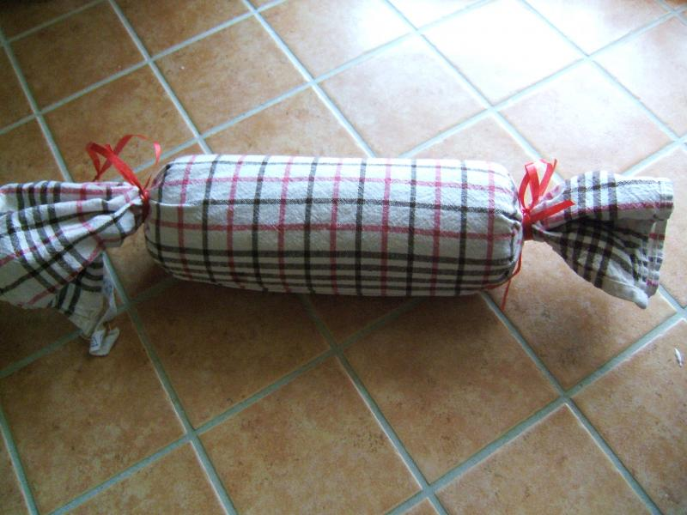](http://www.google.ch/url?sa=i&rct=j&q=&esrc=s&source=images&cd=&cad=rja&uact=8&ved=0ahUKEwjGs-270evRAhWKExoKHWNIAUkQjRwIBw&url=http%3A%2F%2Fwww.chefkoch.de%2Fforum%2F2%2C10%2C463525%2FServiettenknoedel-in-Alufolie.html&psig=AFQjCNEA8J579DjBzZ4StCqyUKdp1WinGw&ust=1485926404357193)