[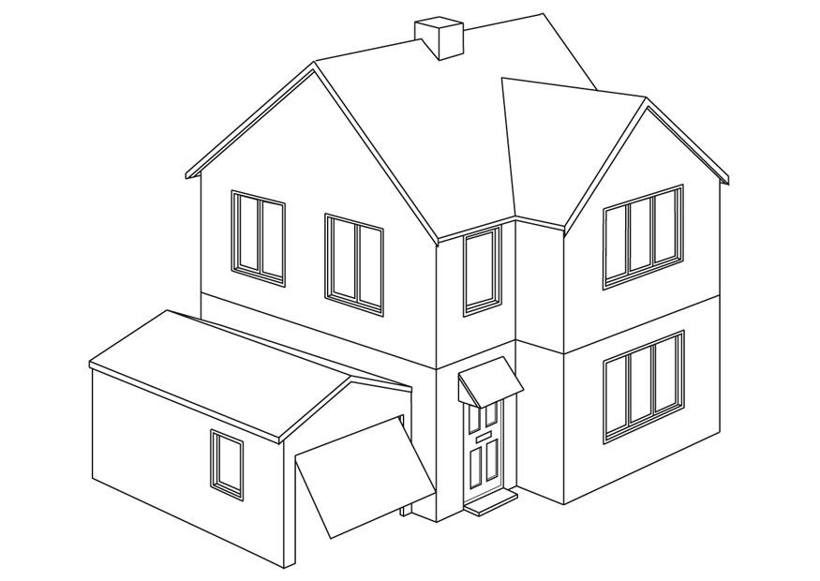](http://www.google.ch/url?sa=i&rct=j&q=&esrc=s&source=images&cd=&cad=rja&uact=8&ved=0ahUKEwi_o9_W067OAhWJXhQKHRYECGUQjRwIBw&url=http%3A%2F%2Fwww.schulbilder.org%2Fmalvorlage-haus-i9454.html&bvm=bv.129391328,d.d24&psig=AFQjCNG_szlYMd8y9SNdBA1xBJvukQnHsA&ust=1470636932504019)

[](javascript:)